The Dragon’s Egg

6. I rushed round the maze, gathering the keys: entrance, triangle, circle, square, and back to the entrance.

“Come on!” barked the fox. “Come on!”

As the sun started to sink on the horizon, the fox bounded down the path to the cliff face. I followed close behind, clutching the keys.

“Come on!” barked the fox. “Come on! Open the door!”

I held up the egg and the door reappeared.

“But I don’t know the right order for the keys!” I said.
“It doesn’t matter,” barked the fox. “They’re all the same. Didn’t you look?”

I put a key into each hole and turned it. As the light dimmed, the door swung open. As the light faded, we hurried through the doorway. As the light died, the door swung shut. It was pitch black.

“That was a close shave,” barked the fox. “Another few seconds and we’d really have been in the soup.”
“Well, I said. “I suppose that would be carrot and coriander soup, to go with the orange tips of your elegant ears.”
“Don’t joke about it!” barked the fox. “It’s really not funny!”
“I suppose it isn’t,” I said, though I did think it was rather funny. “So what do we do now? I can’t see a thing.”
“Use the egg!” barked the fox.

I held up the egg. The egg glowed the colour of sunrise. I looked around. We seemed to be in a very small rectangular box.

“Come on!” barked the fox. “Come on! Select a floor.”
“I don’t understand,” I said.
“Look at the panel!” barked the fox, jumping up and at tapping the right hand wall with a paw.

I held the egg closer to the wall. On the wall was a column of buttons numbered 1 to 9.

“Oh!” I said. “It’s a lift.”
“Of course it’s a lift!” barked the fox. “How else are we going to get to the dragon’s nest? Fly?”
“Which floor do we want?” I said.
“I’ve no idea!” barked the fox. “Read the instructions!”

To the right of the buttons was a notice that read:
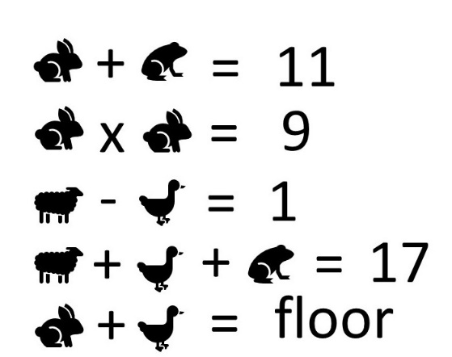

“Oh dear,” I said. “That’s another really hard one.”

I took out my mobile phone, and called Nancy.

“Rabbits!” said Nancy. And put the phone down.

